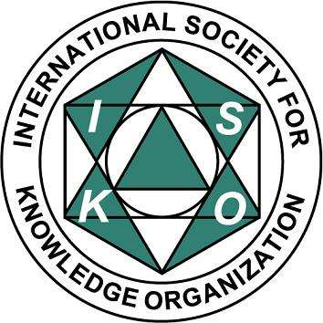
PTIN ISKO PL

XV Forum on Scholarly and Technical Information
“INFORMATION – KNOWLEDGE - INNOVATION
IN THE EUROPEAN RESEARCH AREA”
Kraków, Poland, 18-20 September 2019

organized by the Polish Society for Information Science and International Society for Knowledge Organization - ISKO-PL

REGISTRATION FORM
(Please send to May 15, 2019, e-mail: forum.ptin@gmail.com.pl )

Personal data
- Family name: ………………………………………………………………………………….
- First name(s): ………………………………………………………………………………….
- Academic degree: ……………………………………………………………………………..
- Employed as: …………………………………………………………………………………..
- Affiliation: ……………………………………………………………………………………….
…………………………………………………………………………………………………...
Address: …………………………………………………………………………………………………...
City: …………………………………….. Area code: ……………………………….............
Tel.: ………………… e-mail: …………………………………………………………….......
- The details for the invoice (if Participant wants to receive an invoice):
Name of the institutions: ……………………………………………………………………
Address: ………………………………………………………………………………………..
VAT identification number:………………………………….………………………………...

• Privacy policy *
I agree to the processing of my personal data by the Polish Society for Information Science to organize a conference XV Forum on Scholarly and Technical Information (in accordance with the Regulation (EU) 2016/679 of the European Parliament and of the Council of 27 April 2016 on the protection of natural persons with regard to the processing of personal data and on the free movement of such data, and repealing Directive 95/46/EC. I know that providing data is voluntary and that I have the right to control data processing, the right to access my data and correct it.

Contribution
- Paper(s) title: ………………………………………………………………………………………….. ………
…………………………………………………………………………………………………...
- Abstract and keywords ………. (write it here or send as separate file)

Conference fee payment
The conference fee - participation in all Conference sessions, Conference bag and materials, coffee, lunches (catering) is 350 PLN (80 EUR)
- Payment has to be made by 15 July, 2019, at the last.
- Bank Transfer (after receiving confirmation of participation)
To: POLSKIE TOWARZYSTWO INFORMACJI NAUKOWEJ
Account number: PL 72 1020 2313 0000 3502 0145 1798
BIC (SWIFT CODE): BPKOPLPW
Bank details: PKO BP S.A. Oddział 2 w Katowicach

Important: After bank transfer, please state clearly the “Participant name” and send a copy of the bank receipt by e-mail to: forum.ptin@gmail.com

There is NO reimbursement for travel and accommodation costs.

Do not omit to add: “XV FORUM INT” and the name(s) of the delegate(s).

Date: ………………………….. Name and / or Signature: ………………………………

Please complet this form in capital letters and return by e-mail to:
E-mail to: forum.ptin@gmail.com

